**Talos Origins**

**Game Design Document**

COMP376

Eric Provencher 26543731

Ningge HU 26834051

Eric Philiponna 26225497

## Executive summary

Talos Origins is a two-dimensional procedurally generated action-exploration RPG in a sci-fi setting that focuses on increasing your character’s abilities to unravel the mystery behind his journey.

## Project Description:

With each level being an increasingly large and challenging procedurally generated maze, players will never see the same stage twice. Traversing each maze involves using the breadcrumb mechanic which lets players know where they’ve been, along with the grapple which allows them to effortlessly navigate across the field of asteroids and enemies.

Each stage is filled with a random assortment of enemies that, when killed, release collectible resources that can be spent on improving and expanding the protagonist’s repertoire of abilities, to better serve him on his quest to find his creator, and aid him in conquering the increasingly difficult enemies that stand in his path.

## Gameplay Walkthrough:

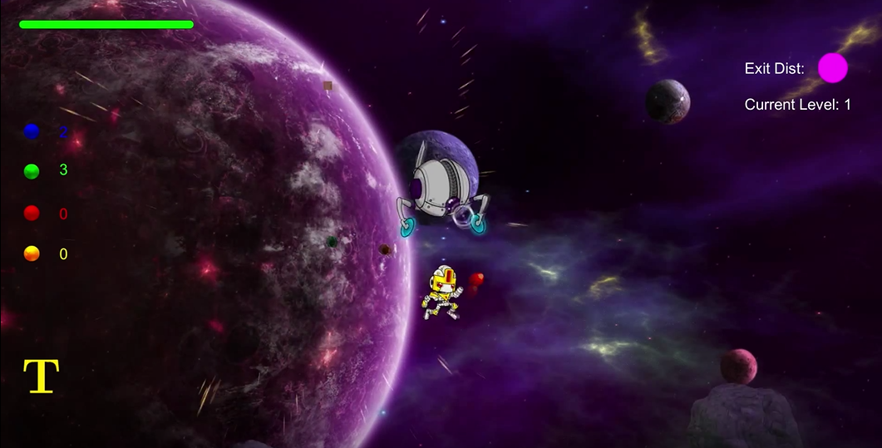

<https://youtu.be/4Shf_nvfwJ8>

## Theme / Setting / Genre

The story a work of Science Fiction that takes place in the middle of a rebellion attempting to destroy a long-standing galactic empire.

The game itself is a two-dimensional roguelike role-playing game that involves platforming, action and strategically managing resources in an effort to progress as far as possible.

## Core Gameplay Mechanics Brief

- Procedurally generated mazes

- Grapple assisted platforming for maze navigation

- Upgradable weapons

- Breadcrumb system to track traversed path

## Targeted platforms

- PC

- Android/iOS (End of development)

# **What sets this project apart**

<Reason #1>

Procedurally generated mazes ensure that players will never see the same level twice

<Reason #2>

Engaging upgrade system entices players to try different strategies to complete levels

<Reason #3>

Infinite progression means that players can keep improving their character and explore increasingly large and challenging mazes.

## Influences (Brief)

### <Game> Super Metroid

Super Metroid was the first 16-bit entry of the series, featuring vast worlds to explore, with complex power-ups to be gained along the adventure. The game’s story is told in small pieces, but the purpose of the adventure is largely shrouded in mystery. Talos Origins will have a very similar feature a very similar upgrade system, with Super Metroid serving as a strong inspiration for atmosphere, platforming and overall feel.

### <Book> Foundation

The Foundation series built an incredibly detailed tale of a galactic empire with morally gray opposing characters. This series will serve as an inspiration for our game’s plot forks, that will allow the player to make decisions that will shape the fate of the galaxy.

### <Game> The Binding of Isaac

This game features a procedurally generated collection of rooms, filled with randomly placed enemies and boss battles, along with a complex item system. It is a needlessly difficult game, but it works because the player improves and can make their way further on each play through. Due to the RPG nature of Talos Origins, the player won’t be as severely punished on death, but the difficulty will certainly ramp up in a similar fashion.

### <Game/Comic> Spiderman

Spiderman’s motion, momentum and swinging are incredibly interesting as gameplay mechanics and went a long way towards inspiring the movement and feel of Talos’ motion and grapple mechanics.

## Story (Brief)

After years of searching, Talos has tracked down his creator who is building an army to overthrow the peaceful Galactic Empire he helped build with his robotic overseers.

## Story (Detailed)

Talos is robot whose only purpose has been to serve the will of his benevolent masters. Amid the increasing unrest spawned from calculated attacks throughout the great Galactic Empire, the Overseers have sent Talos out into the Galaxy, on a search to find the source of these attacks, and put an end to the uprising.

After years of searching, the game begins with our protagonist’s arrival in the Aeos System, where he must traverse the Hieran Asteroid field and find and stop the growing rebellious army. Talos doesn’t know that their leader is in fact his creator, and the very same person who created the Overseers that control Galactic Empire.

Throughout his quest, our protagonist will face many God-like entities who will reveal their motivations for standing against the will of the Overseers, and each such encounter will lead Talos to question his motivations, such that by the time he finally discovers his creator, he will have to make a decision that will shape the future of the Galaxy.

## World

The game takes place in the Aeos System, during unrest caused by calculated attacks throughout the great Galactic Empire. Talos has been sent here by the overseers to bring peace to the galaxy by finding the source of these attacks and put an end to the uprising.

The game take place more specifically in the Hieran Asteroid field the home of many hostile creatures who are destined to protect their creator (the leader of the rebellion attacks). In order to fulfill his mission, Talos must find his way through a maze of portals which will eventually lead him to his master.

## Characters

<TALOS>

Talos is a robot bounty hunter sent by the Overseers to put an end to the galactic rebellions. Fueled by a tireless will to see galactic order, Talos will stop at nothing to find the source of these rebellions, and put an end to their leadership. What he doesn’t yet know, is that the rebel leader is in fact his creator, which will put an immense amount of tension on the decision to take when they finally meet.

Equipped with an advanced power armor, an energy shield, a grapple and a plasma blaster, Talos has all the tools he needs to face enemies in the field. His ship serves as a base of activities which can help him craft upgrades with the resources collected, and his inter-dimensional teleported allows him to travel to unknown alternate universes.

<THE CREATOR>

Little is known about The Creator. He or she is a mysterious figure behind the galactic rebellions, which have caused countless causalities throughout the galaxy, and is amassing an army to put an end to the galactic empire once and for all.

<CRAWLER DRONE>

The crawler drone is a mindless automaton who serves the creator and tirelessly pursues intruders, while also lobbing destructive bombs that have been known to cause friendly causalities. Crawlers are insect-like robotic creatures, with fearsome red eyes, capable of scaling walls and navigating the treacherous mazes to pursue Talos.

<SEEKER DRONE>

The seeker is another automaton, who has been fitted with the ability to float through space. They can come from any direction, and charge intruders with deadly force, or destroy the asteroids tethered to Talos via his grapple. Seekers are while orb-like creatures that often travel in groups.

## Player Composites

Christopher Dubois, 23, single, Computer Science student at McGill, plays games alone almost every day. Likes to play games on computers because he is with his computer all the time. Likes to play some small but interesting games at noon after lunch, or after a long study in the library, as a relax, with pleasant but effortless. Interested in astronomy, outer space, and all games with science fiction elements. Likes fun shooting games without blood or violence, and games with cute characters.

*“I’ve been part of Talos Origins as a game tester since the first alpha builds of the game. My task, as I saw it, was to play the game as organically as possible, to give feedback not only about obvious bugs, but also on the meta aspects of the game that made it enjoyable. My experience has morphed from update to update, much like the game itself. What begun as commentary on faulty physics and jerky player on enemy interaction eventually became the subjective suggestions of a fan that just wanted Talos to be perfect. I’m sure, with another six months of development and some intelligently directed expansion, it could be. Watching this clumsy side-scroller mature into a legitimate action shooter has left me in awe at the subtle affects that animation and audio can have on the player. In its final stages, Talos has become increasingly immersive leading it on the path towards a legitimate game. Despite numerous tweaks that needed performing from the get go, I’ve never found testing this game to be a chore. Rather, watching the formation of such software has allowed me to see more deeply into the creator’s intention. It was fun, and I’ll be first in line to get a glimpse of the finished product.”*

* **James McCafferty** – McGill Psychology/Computer Science double major

## Progression Graph

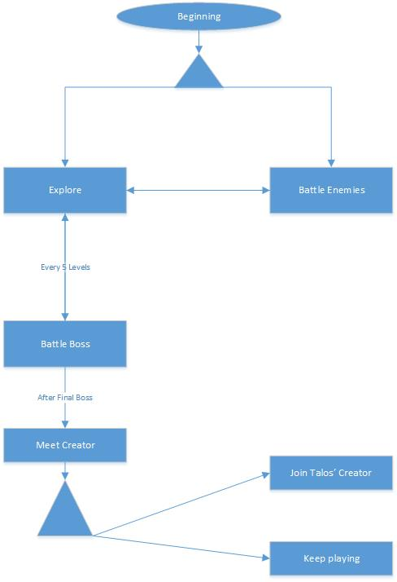

## Art Direction

<Wall Materials>

The maze generator creates a mesh that can be fitted with a customized material. These materials are taken from a basic materials asset created by Integrity Software & Games, called PBS Materials Variety Pack available for free on the Unity Asset Store.

<https://www.assetstore.unity3d.com/en/#!/content/34607>

<Space themed art assets>

The game’s portals, shields and background are modified from a very nice 3D space asset pack created by Prodigious Creations, available for free on the Unity Asset Store.

<https://www.assetstore.unity3d.com/en/#!/content/38913>

<Talos>

Talos is a robot bounty hunter, but given the light spirit of this game, he needed to appear powerful, but not scary. His design was taken from a generous sprite designer on OpenGameArt.org, of the name pzUH. The sprite sheet can be found here: <http://opengameart.org/content/the-robot-free-sprite>

<Crawler>

The crawler is a robotic insect-like creature that is both menacing due to his all-terrain movement, and his bombs that unleash utter devastation. The design for the bombs and the creature itself were done by an artists of the name ridjam, whose profile can be found here: <https://dribbble.com/shots/2106284-Robot-Cockroach-Game-Enemies-Sprite>

<Seeker>

The seeker is a robotic hovering orb creature that moves around in a very unpredictable manor. The design and sprite drawing for this enemy were done specifically for this game by Mathieu Dubois.

## Sounds

The game’s sound designed was done by Jonathan Cohen, a talented sound engineering student who was interested in bringing this game to life by helping create unique audio clips to be deployed as necessary in-game.

The sounds designed include:

- Asteroid Exploding

- Atmospheric Music track

- Bullet Fired

- Bullet Hitting Enemy

- Button Clicked

- Crawler Bomb Firing

- Enemy Exploding

- Grapple Firing

- Grapple Hitting surface

- Grapple Reeling

- Jump Sounds

- Orb Collected

- Pain Sounds

- Portal Sounds

- Recharge Sounds

Each of these sound clips are attached to a prefab game object, along with a script that destroys the object 2 seconds after deployment. This permits the liberal instantiation of sounds, in addition to utilizing Unity’s spatial sound engine, which changes volume according to distance.

## Animation

< Environment Animations >

The game’s backgrounds are composed of a combination of a static space wallpaper, along with moving planetary and star elements that are assigned a new direction every x seconds, where x is a random prime. This makes the backgrounds appear to have depth, while giving a sense of motion found when exploring a celestial body in orbit of a planet.

<Talos>

Talos’ animations consist of:

* Walking
* Jumping
* Shooting Walking
* Shooting Jumping

He’s also equipped with a shielding device that is deployed upon being injured, and along with the portal, is animated by a scale which varies its scale.

<Crawler>

The crawler’s simplistic movement mean that it’s animation states are either walking, or standing still. These are controlled by a standard animation controller. However, the crawler also possesses the ability to walk along walls, and must therefore have its rotation aligned by a script, in order to match the surface it is currently moving along.

<Seeker>

The seeker’s animations are dictated by the direction of movement, and are executed by a simple finite state machine in the animation controller.

## UI Storyboards

## 





## Tags and dialogue

While there was initially a plan to have a comprehensive story and dialogue system, a lack of time forced us to focus on the core gameplay. As such the game is devoid of any dialogue.

There is a menu system in place which does have descriptive text to explain the purpose of upgrades to the player, in addition to allowing the player to save and quit, along with restore at a specific point in the game. However, there is no complex database and indexing scheme to make way for localization to other areas, and it would have to be conducted manually.

## Technology Plan

The game has been built from the ground-up using Unity3D’s various engine features.

While the game is 2D, it makes use of a mesh for the maze, along with 3D asteroids, that are both fitted with materials that glow and shimmer when exposed to a dynamic light created with Unity’s lighting engine.

The main character and enemies are rendered using simple 2D sprite renderers, so they unfortunately are not compatible with the dynamic lighting system.

The physics in the game are built using basic 2D rigidbody and collider mechanics, and they serve to add a very interesting feel of weight and motion that make the player and enemies move far more naturally than they would otherwise.

The particle physics in the game are built using Unity’s particle system framework, which allows for a very wide range of possible diffusion and burst effects.

The UI is built using Unity’s Canvas renderer, and customized with the various UI tools built straight into the bundled UI assets.

## Software Architecture

## Code

- Character Scripts

<Grapple Handling>

<Weapon Handling>

<Character Controller>

- Map Generation Scripts

<Maze generation>

* + - Random path and exploration tunnels based on random density parameter
    - Asteroid and Enemy Generation and scaling
    - Start and Exit Handling

<Mesh generation>

Marching Squares algorithm for generation of cavern from bit array

- NPC Scripts

Enemy AI Controller (Handles all organization for enemy types)

* + - Crawler Wall sticking algorithm, which works by using raycasts to create an average floor distance, and repositions the crawler’s normal to match the surface currently being walked on.
    - Seeker movement logic, which finds a direction that is either random, or in the direction of the player character, in addition to readjusting its direction based on obstacles.
    - Communication with Player and Map Generation Scripts

- UI Controller

The game’s upgrades menu is handled by a simple UI controller attached to each upgrade element, thus allowing for scalable upgrades, while permitting save-states for non-continuous gameplay sessions.

## Controls

|  |  |
| --- | --- |
| Control | Description |
| A/D | Move Left / Right |
| Space | Jump /Release Grapple |
| Left Mouse Button | Shoot |
| Right Mouse Button | Deploy Grapple |
| w | Reel grapple up |
| T | Deploy Portal |
| TaB | Open Shop |
| P | Pause |
| R | Reset Breadcrumbs |

## Level Design

The game’s levels are designed to be scalable and random. The major focus behind scalability is obstacle and enemy density, along with enemy difficulty, all varied upon according the current level. Enemies and asteroids, being of different sizes, also scale in their difficulty to destroy.

The cave generator includes a parameter for fill-density, which when lowered, allows for greater freedom of vertical movement, at the cost of being empty. This is countered by the inclusion of randomly distributed asteroids, that aid the player in navigating these open spaces.

While the caves can be built to great vertical and horizontal sizes, navigating massive vertical mazes can be extremely challenging. As such, the maze generation restricts the height component to allow for a more traditional horizontal-leaning general direction.

One the player spawn location has been decided at random, the exit is positioned at an open space, at a random location, favoring distance between it and the player. The side-effect of this approach, is that the exit tends to be located right-bound from the player. While the exit may not always be in this direction, the early, smaller levels typically follow this pattern, thus making it easier for the player to locate the exit. As the levels progress however, the mazes grow both vertically and horizontally, thus allowing for a greater variety in exploration and challenge.

The level generator has been balanced and optimized to allow the game’s flow to continue unbounded, with increasing enemy difficulty and level size. There is however a hard limit on enemy and asteroid population at approximately 400 each per level, which only becomes apparent around the 600-700 level mark.

## Core Gameplay Mechanics

### 2D Projectile Combat

<Details>

The game is based around combat between Talos and multiple types of enemies. Talos can fire bullets at the enemies in order to afflict damage upon them. Defeating an enemy Talos is rewarded with currency and also contributes to the player’s game progression.

<How it works>

Talos is equipped with a blaster gun which is his only mode of defense against enemies, and ammunition is unlimited. Once Talos defeats an enemy or destroys an asteroid, it will release orbs, which serve as a currency to purchase upgrades be used towards upgrade (see “Upgrades System” below). Talos will need to explore randomly generated mazes to reach the exit of each level, and move on to larger and more difficult mazes that house increasingly dangerous enemies, who release increasingly large amounts of orbs.

### Upgrades System

<Details>

At any time during the game Talos can open his upgrades computer, which will let him consume the resources he has gathered to improve his arsenal, and improve his odds for survival. Upgrades include larger bullets, explosive bullets, rage mode (damage multiplier), a force field shield, health packs, increased max health, increased jumping, breadcrumbs and a longer grapple.

<How it works>

Defeated enemies, or destroyed asteroids release orbs that must be captured. Upon capture, orbs are converted into a universal currency depending on their value. Each upgrade’s price will be scaled according to its level.

**Randomly generated cave maze**

<Details>

Each map is randomly generated allowing for a completely new layout, even for mazes of the same level. Each random level features a variety of different sized enemies and asteroids, along with a different fill density of the maze layout. With a lower fill density, asteroids and enemies are more spaced out, and large open spaces allow for a more aerial-based level progression. Higher density levels can be more claustrophobic, while also being more difficult to navigate.

<How it works>

As the player advances in the game, the maps will grow in order to accommodate for extra, more difficult to kill enemies, along with more asteroids, leading to potentially even crazier aerial battles and adventures, while also making it more difficult to find the exit.

Every five seconds, the player can trigger a wormhole which will take Talos to an alternate level, which may be easier or more difficult. This can be a useful escape in dire situations, but does not guarantee Talos won’t be worse off because of it.

### Orbs

<Details>

Throughout his adventures, Talos will encounter a number of orbs that can be converted into health or currency, obtained from defeating enemies or destroying asteroids.

<How it works>

Yellow orbs are worth the least, but will also heal a small amount of health, while red orbs are worth slightly more, but will not heal anything. Green and blue orbs are most valuable, but can only be obtained from defeating enemies.

### Grapple Hook

<Details>

Talos is equipped with a grapple hook in order to allow him to navigate through each cave with ease no matter the size. It can serve as an “elevator” to climb up the maze, or as a swing explore quickly or even to avoid enemies.

Together with the large open spaces, and floating asteroids found in the caves, the grapple hook allows for some exciting battle scenes.

<How it works>

Talos can hook his grapple onto any wall or asteroid given that it is within a distance corresponding to his grapple’s range. The player can also reel himself up, swing side to side, release, or jump release from the grapple at any time.

## Schedule

### - <Create Map Generator>

- September 30th

### - <Character Physics and Exploration>

- October 7th

### - <Shooting mechanic + enemies>

- October 14th

### - <Logical Random Enemy Placement>

- October 21st

### - <Improved Enemies + Proper AI>

- October 28th

### - <Visual Particle Effects>

- November 4th

### - <Crawler Enemy Walk on Walls>

- October 28th

### - <Upgrade System>

- November 11th

### - <UI Overhaul>

- November 18th

### - <Gameplay Balance>

- November 27th

## Issue Tracking

Talos Origins is setup on a private GitHub Repository in order to facilitate development progress and ensure that we can always access functional builds of the game by reverting faulty commits if necessary.   
  
The screenshots below showcase our issue tracking, which allows us to assign team members with specific tasks, along with openly offering feedback for specific changes.

OPEN ISSUES

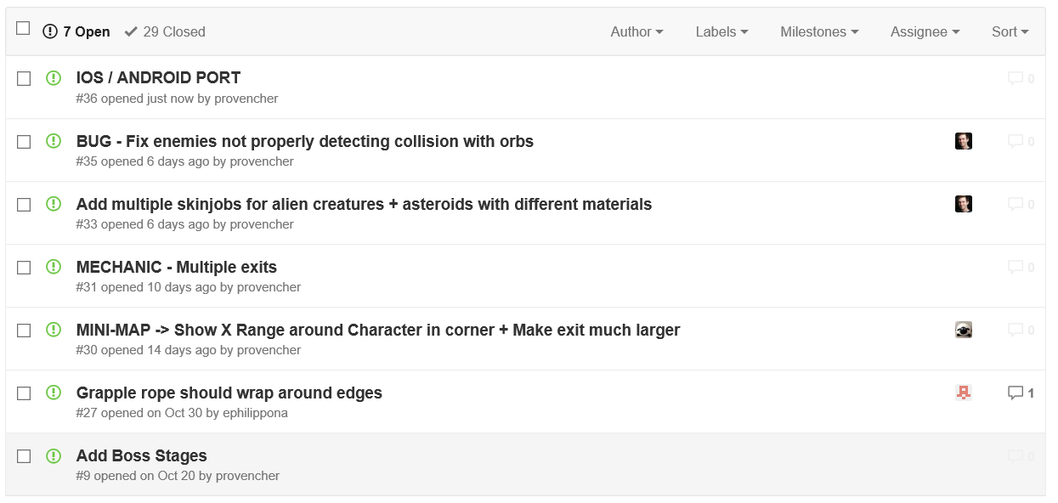

CLOSED ISSUES

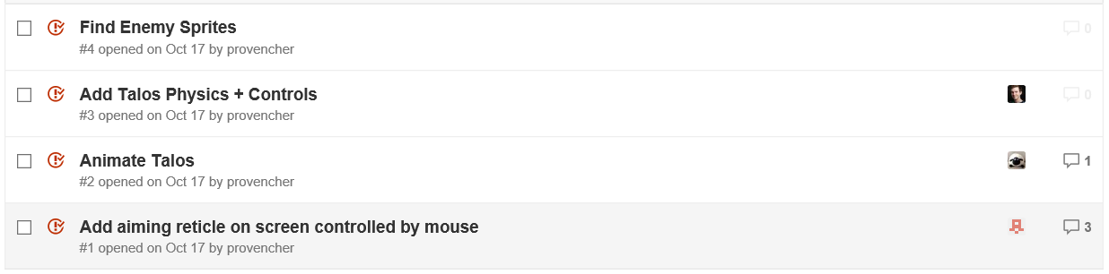

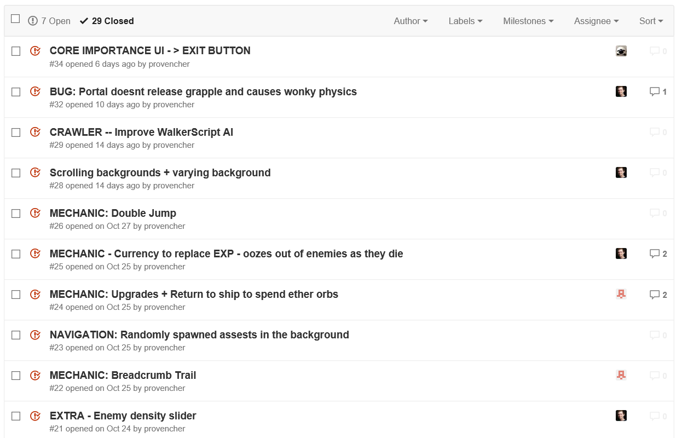

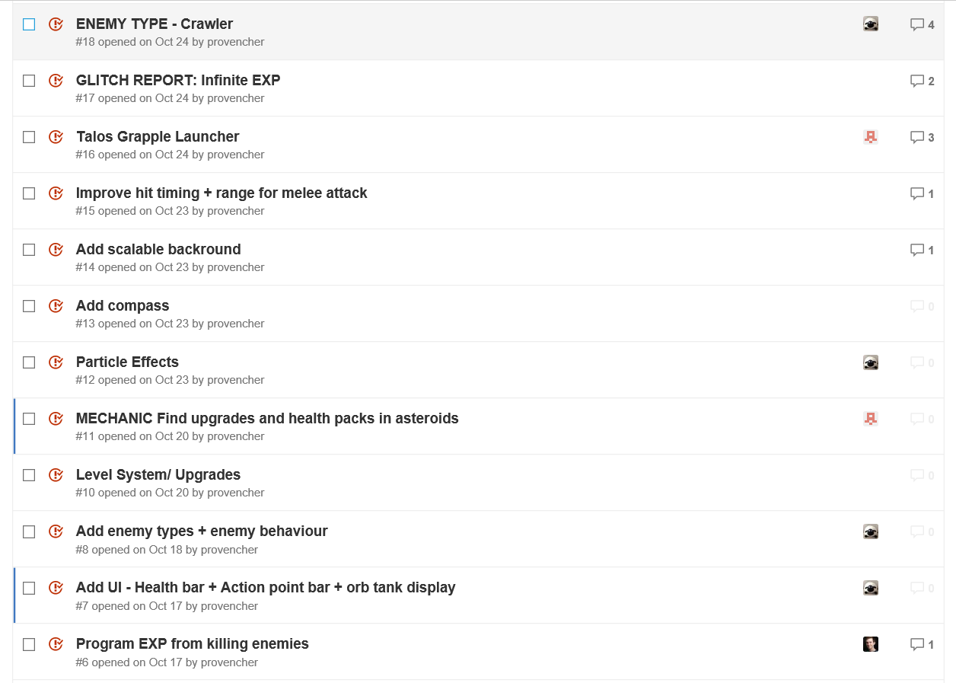

## Change Log

* Added MapGenerator
* Added Player
* Improved Player controls
* Added Player Gun
* Added Seeker Enemy
* Added Crawler Enemy
* Added Grapple
* Added destructible asteroids throughout the levels after playtesters reported a lack of items to grapple onto in large open spaces
* Added Orb Currency to replace experience accumulation
* Added Initial Shop UI, implemented as separate scene
* Modified Shop UI to work on standard scene, for seemless upgrades
* Increased enemy damage after Playtesters reported a strong difficulty in dying
* Added boss battles against really large and difficult enemies
* Removed boss battles in favor of scaled enemies and asteroids
* Changed Shop UI from Drag And Drop to “uncapped” scaled upgrades in order to add a stronger sense of progression
* Modified level generator to make smaller levels that scale better on higher levels (200+)

## TimeSheets

|  |  |  |
| --- | --- | --- |
| **Team Discussions** |  |  |
| **DATE** | **Time Spent (hours)** | **What was worked on** |
| 9/15/2015 | 0.50 | Initial project discussion. Idea for proceduraly generated game. 3D RPG |
| 9/18/2015 | 0.25 | Scrapped ambitions for 3D game, decided on 2D procedural generation. |
| 9/20/2015 | 1.00 | Discussed story, art and inspirations for game. |
| 9/22/2015 | 0.25 | Game Proposal Presentation |
| 9/29/2015 | 0.50 | Discussion on task splitting and implementation details. |
| 10/14/2015 | 1.50 | Setting up of online repository and issue tracker establishment |
| 10/15/2015 | 0.50 | Online discussion on map creation. |
| 10/18/2015 | 0.25 | Online discussion on player control |
| 10/20/2015 | 0.25 | Online discussion on enemy types |
| 10/23/2015 | 1.50 | Playtesting and discussion of glitches and mechanic improvement ideas |
| 10/24/2015 | 1.00 | Online collaborative trouble shooting on various issues. |
| 10/27/2015 | 0.50 | Discussion on remaining tasks and issues |
| 10/29/2015 | 0.50 | Online discussion on Gameplay mechanics |
| 10/31/2015 | 1.5 | Work on Game Design Document + Presentation |
| 11/10/2015 | 1.00 | Discussion on remaining tasks and issues |
| 11/13/2015 | 0.5 | Discussion of tasks splitting for weekend work |
| 11/17/2015 | 0.50 | Discussion on finalizing Missing UI + Upgrade Components |
| 11/24/2015 | 0.5 | Discussion on final tweaks and balance adjustments to brind to the game |
| 11/5/2015 | 0.25 | Game Design doc |
| 11/30/2015 | 1.0 | Meeting to discuss remaining polish |
| 12/1/2015 | 0.50 | Meeting to discuss game demo |
|  | **TOTAL HOURS** |  |
|  | 14.25 |  |

|  |  |  |
| --- | --- | --- |
| ERIC PROVENCHER | |  |
| **DATE** | **Time Spent (hours)** | **What I worked on** |
| 10/14/2015 | 3.0 | Tutorials + implementation for Random map Gen |
| 10/15/2015 | 5.5 | Implementation of Random Map Gen + Player programming |
| 10/17/2015 | 1.0 | Added Exit sign to map in random room |
| 10/18/2015 | 1.5 | Added random enemy spawning |
| 10/20/2015 | 1.5 | Put work into enemy movement logic and gameobject communication |
| 10/22/2015 | 2.0 | Drastically improved enemy spawning + enemy has flying AI |
| 10/23/2015 | 3.5 | Lots of refactoring + Debug UI + Health + Killing Enemies + NextLevel |
| 10/24/2015 | 2.0 | Improved shooting and Talos controls |
| 10/27/2015 | 1.0 | Fixed crawler enemy animator + added damage from bullet generated |
| 10/30/2015 | 2.0 | Bug Fixing + Game play tweaks |
| 10/31/2015 | 2.0 | Spawning logic + reverted accidentally discarded changes + gameplay tweaks |
| 10/31/2015 | 2.0 | Added Asteroids and tweaked grapple to attach to enemies and asteroids |
| 11/1/2015 | 1.5 | Bug fixes for Enemy Spawning + Explosions to Enemies + Minor Tweaks |
| 11/4/2015 | 2.0 | Added Orbs + Lighting |
| 11/8/2015 | 3.0 | Audio Prefab Framework + Fixed Glitches |
| 11/11/2015 | 2.5 | Visual Effects + bug fixes |
| 11/12/2015 | 1.5 | Bug Fixes |
| 11/13/2015 | 1.0 | Enemy AI groundwork |
| 11/14/2015 | 5.0 | Ressearch into raycast assisted movement stabalization |
| 11/15/2015 | 3.5 | Implementation of racast assisted movement stablization |
| 11/16/2015 | 3.0 | Missing Audio added + effects and visuals + portal |
| 11/17/2015 | 2.5 | Work On Walker Script AI + Sun in center |
| 11/18/2015 | 2.0 | Work On Game Design Document + Walker Script improvements |
| 11/19/2015 | 2.5 | Crawler pretty much final |
| 11/20/2015 | 2.0 | Game Balance Tweaks + Crawler Balancing |
| 11/21/2015 | 1.5 | Much better background |
| 11/22/2015 | 1.5 | Enemy balance + Currency distribution balance + Music track addition |
| 11/23/2015 | 5.0 | Significant visual overhaul + Gameplay balancing |
| 11/24/2015 | 5.0 | Audio balancing + Modified enemy parameters for scalability |
| 11/25/2015 | 4.0 | Significant Refactoring of Map Generator to improve map layout |
| 11/26/2015 | 3.0 | Balanced Map Generator + Tweaked randomization |
| 11/27/2015 | 3.0 | Balanced Game for Really high levels (200+) + Major bug and stability fixes |
| 11/28/2015 | 3.0 | UI Cleanup + Video Capture + Added Main Menu |
| 11/29/2015 | 1.0 | Balancing as a response to player feedback |
| 11/30/2015 | 1.5 | Added multi-bullet upgrade |
| 12/1/2015 | 2.0 | Balancing as a response to player feedback |
|  | **TOTAL HOURS** |  |
|  | 89.5 |  |

|  |  |  |
| --- | --- | --- |
| ERIC PHILIPPONA | |  |
| **DATE** | **Time Spent (hours)** | **What I worked on** |
| 27/10/15 | 3.0 | Grapple research and development + aiming reticle |
| 28/10/15 | 1.0 | Breadcrumbs |
| 1/11/2015 | 4.0 | Create Shop UI (includes drag + drop mechanic, particles, upgade cards,…) |
| 1/11/2015 | 1.5 | Tweaks to shop UI + Persistence research |
| 5/11/2015 | 3.0 | Ingrate currency |
| 2/11/2015 | 3.0 | Add shop as canvas in main scene |
| 10/11/2015 | 3.0 | Upgrades mechanics |
| 20/11/15 | 2.0 | Tweaks to Shop UI (balancing currency, + unblock upgrades to infiniti) |
| 24/11/15 | 1.0 | Balance upgrades |
| 27/11/15 | 1.5 | New upgrades( portal distance, cooldown, # of bullets) |
| 28/11/15 | 1.0 | Bug fixes |
| 29/11/15 | 1.0 | UI Audio |
| 30/11/15 | 4.0 | Major UI Cleanup + Balancing of upgrade power and costs |
|  | **TOTAL HOURS** |  |
|  | 29.0 |  |

|  |  |  |
| --- | --- | --- |
| HU NINGGE |  |  |
| **DATE** | **Time Spent (hours)** | **What I worked on** |
| 10/22/2015 | 4.5 | Talos animations + Talos controls + Talos bullet animations  + Talos shoot bullet to the position where the left mouse button pressed |
| 10/23/2015 | 2.5 | Change Talos bullet to particle |
| 10/25/2015 | 4.5 | Add crawler enemy + Crawler animations  + crawler bullet animations + crawler shoot bullet towards Talos |
| 11/22/2015 | 3.5 | Work on UI |
| 11/23/2015 | 2.5 | Improved UI |
| 11/29/2015 | 2.5 | Added Pause Menu |
| 11/30/2015 | 1.5 | Improved UI for pause menu |
|  | **TOTAL HOURS** |  |
|  | 21.5 |  |